- Put name, ticket type, project, planning activity (Activity_1) on ticket and save
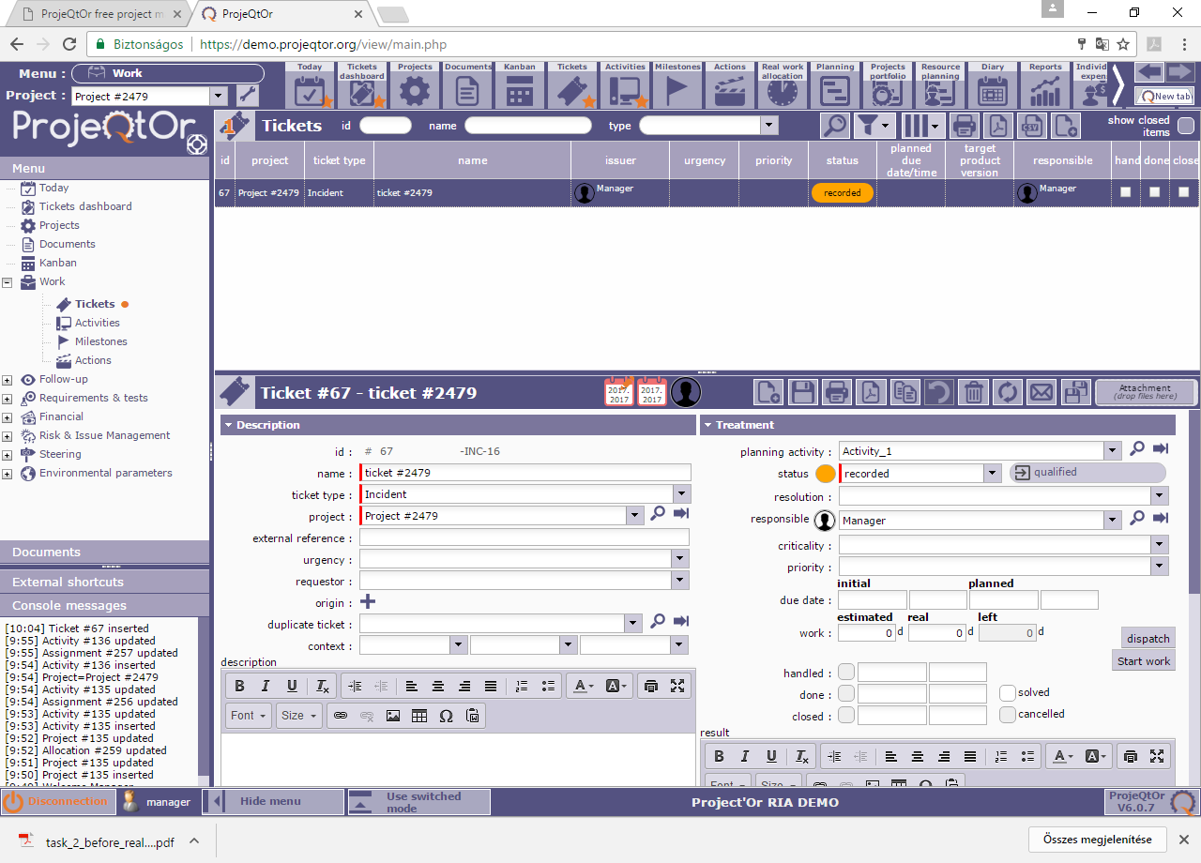
- Click dispatch and put real work on and then click OK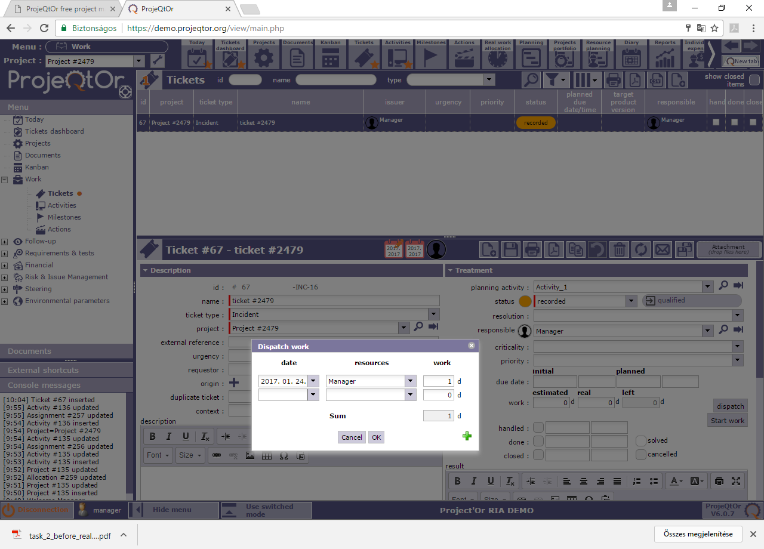
- Then ticket shows the correct datas
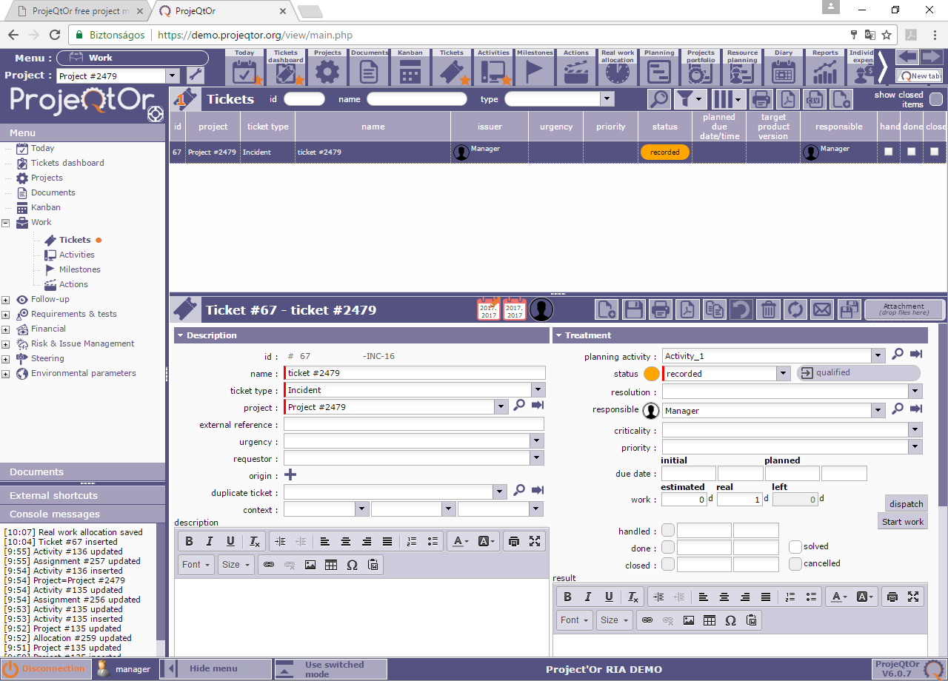

- Than go to activity (Work/Activities menu) and take a look on the Activities
Activity_1 shows this:
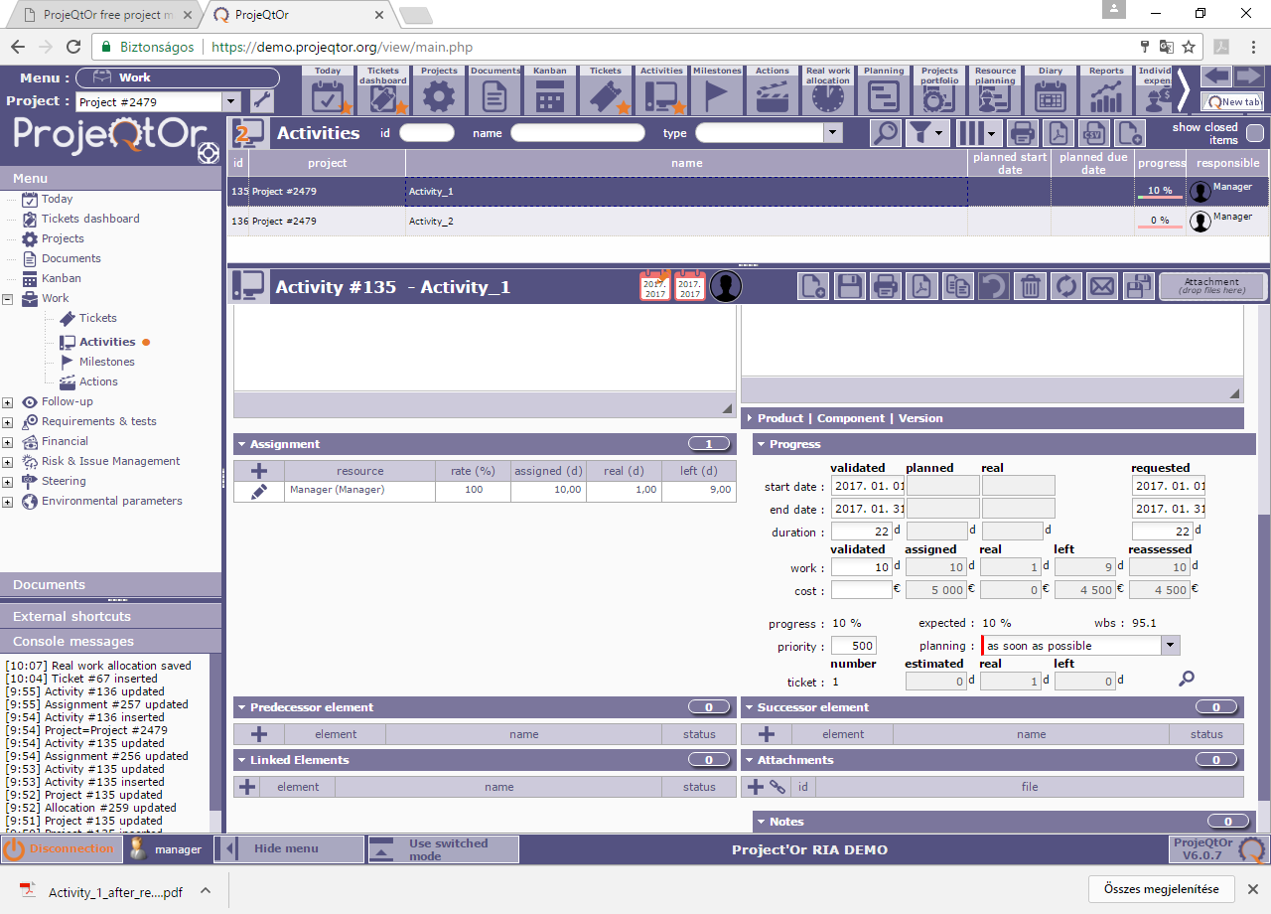

Activity_2 shows this
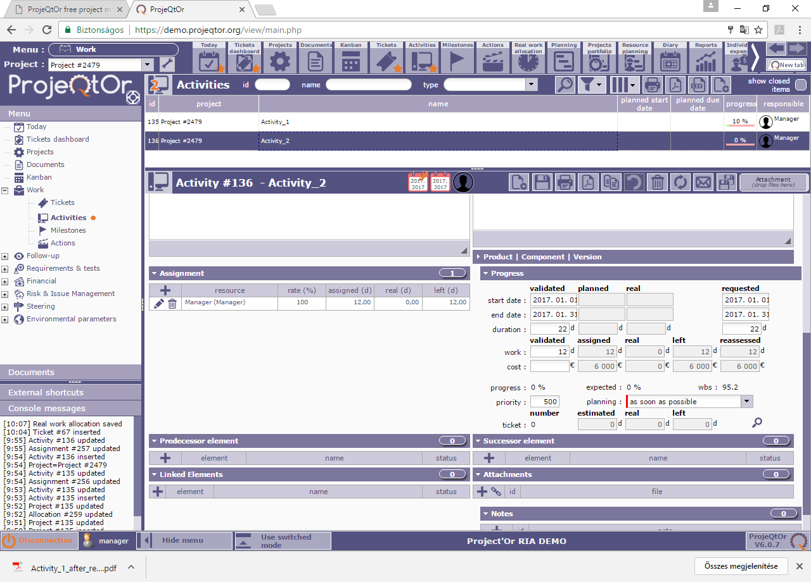
- Go back to ticket, you can see that planning activity is not changeable
