- Click dispatch and delete dispatch work
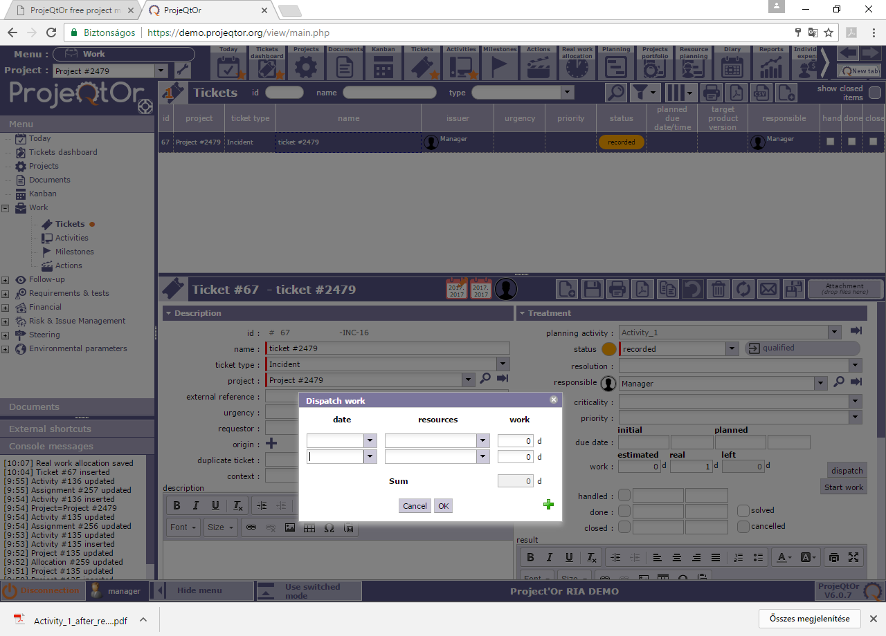
- then click OK, can see that real work is 0 and activity is still not changeable
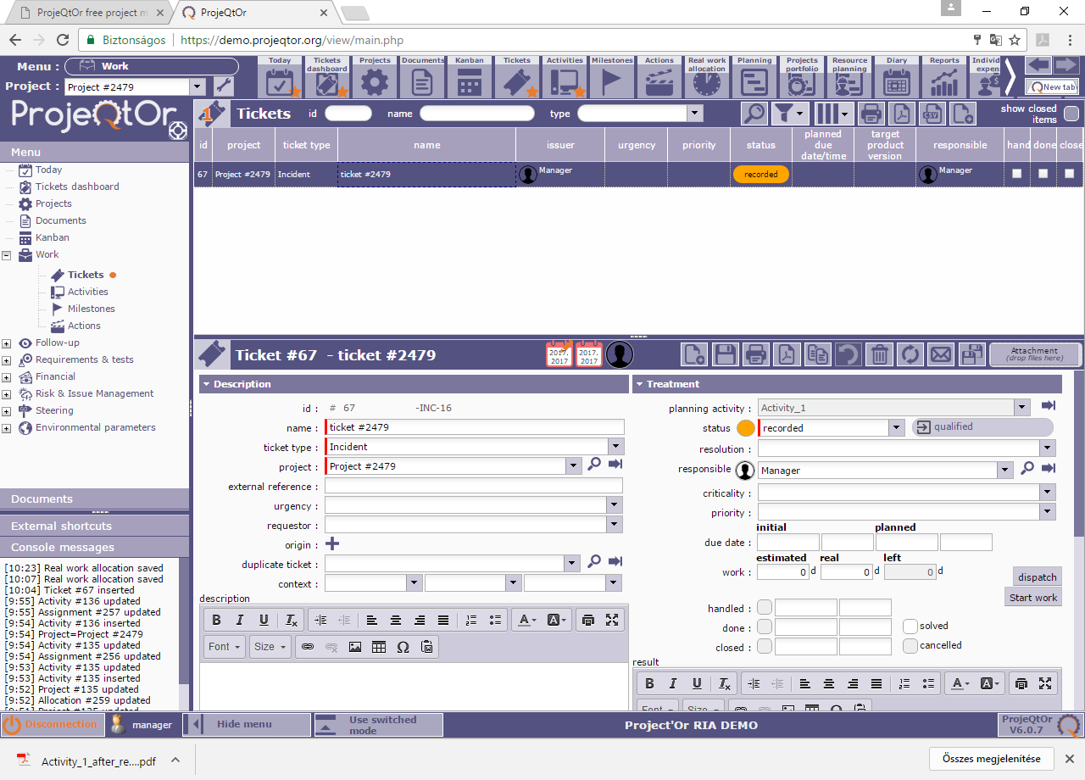
- Refresh ticket list, now you can change planning activity

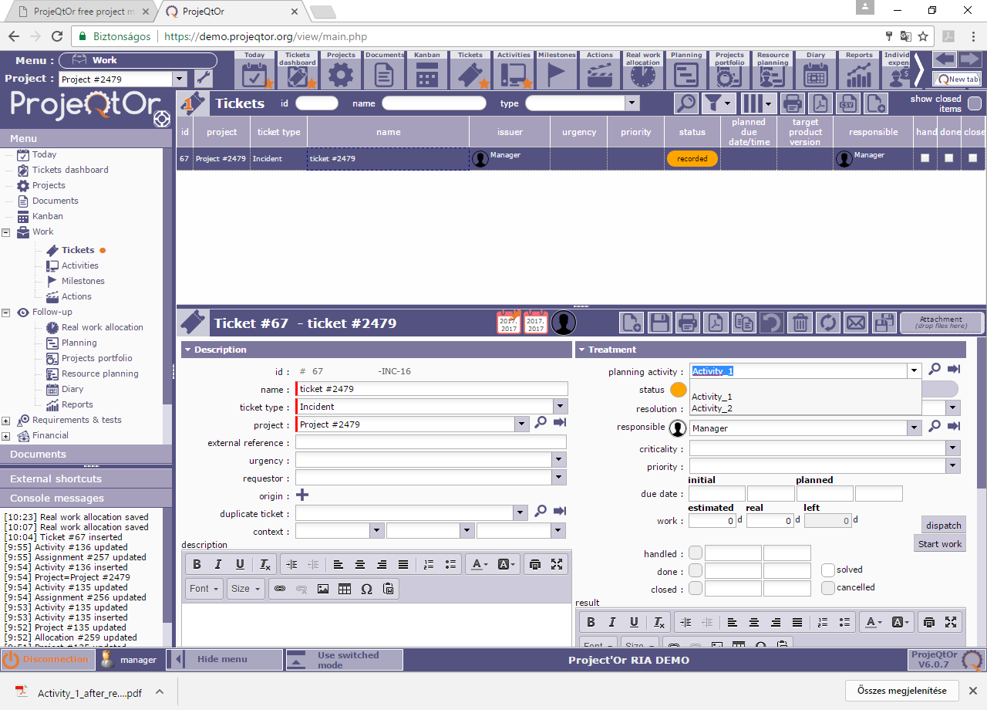
- Choose activity_2 and save
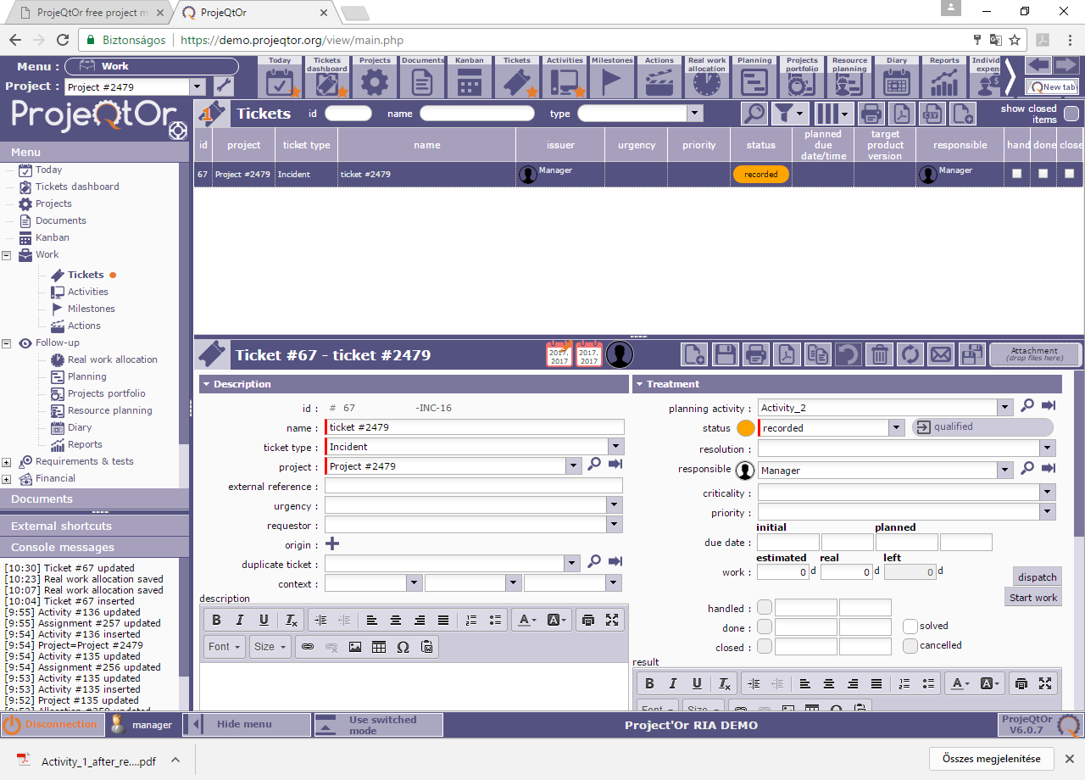
- Click dispatch and put dispatch work and click OK
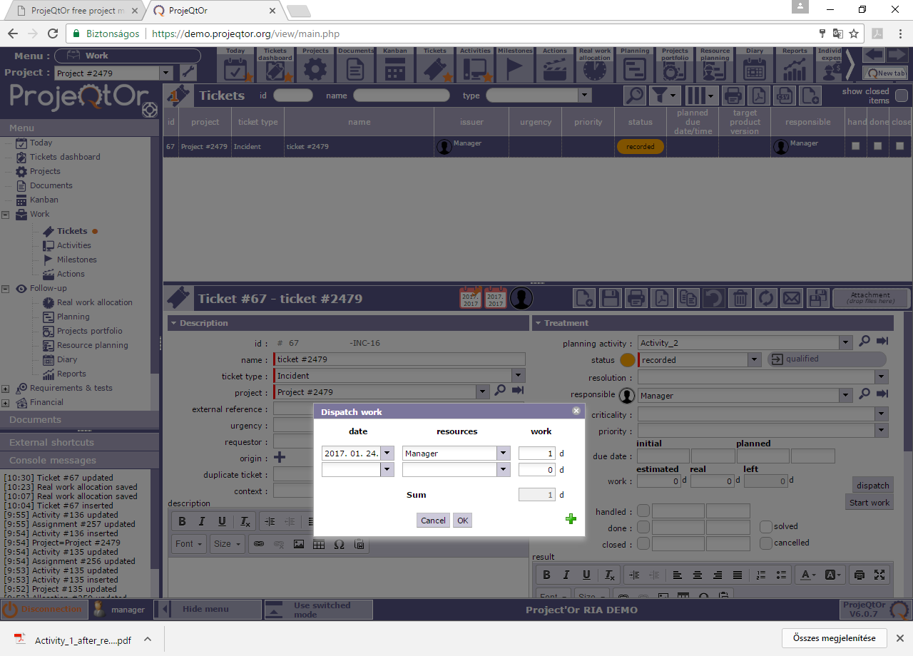
- The ticket now shows Activity_2 with 1 day real work on.
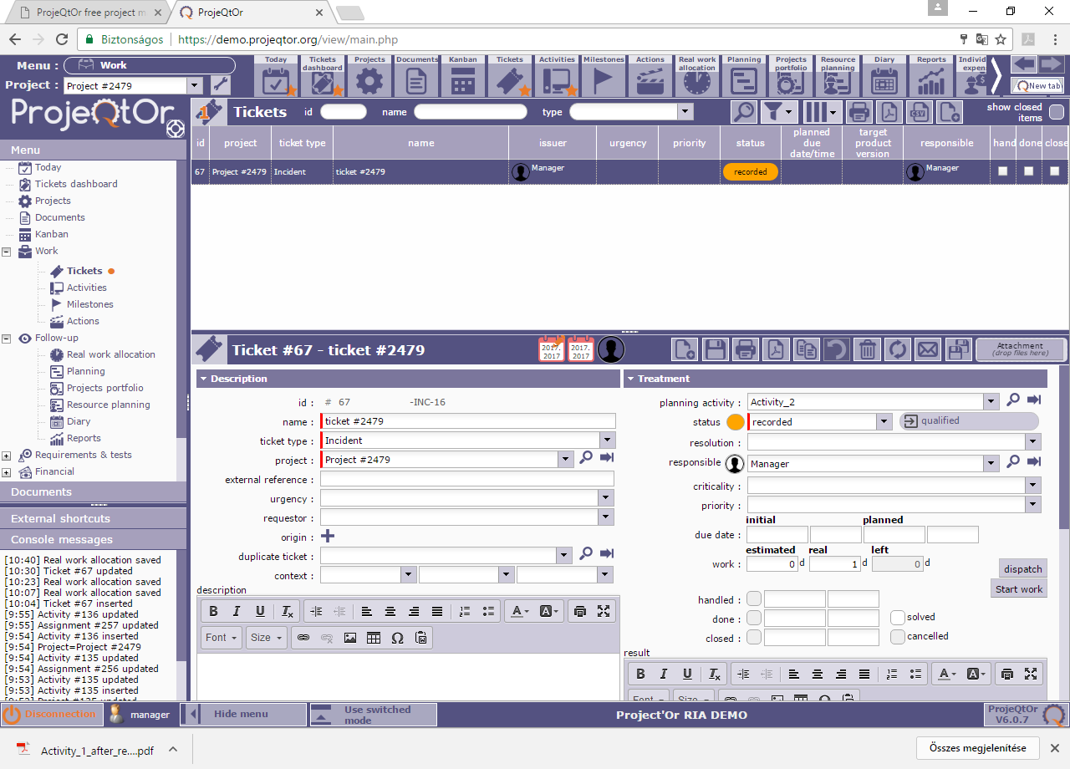
- Go back to Activities:
Here on Activity_1 you can see 1day real work next to the validated work (this is incorrect) and 0 day real work on the ticket (this is correct).
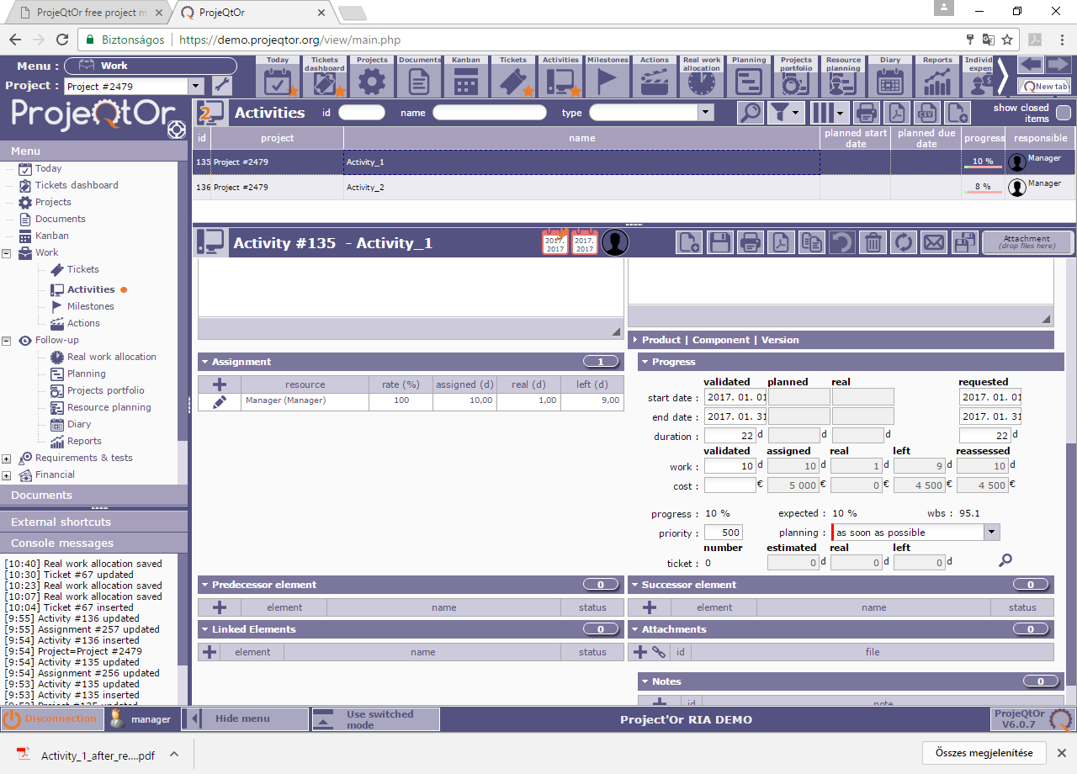
And on Activity_2 you can see 1 day real work next to the validated work (this is correct) and 1 day real work ont he ticket (this is correct)
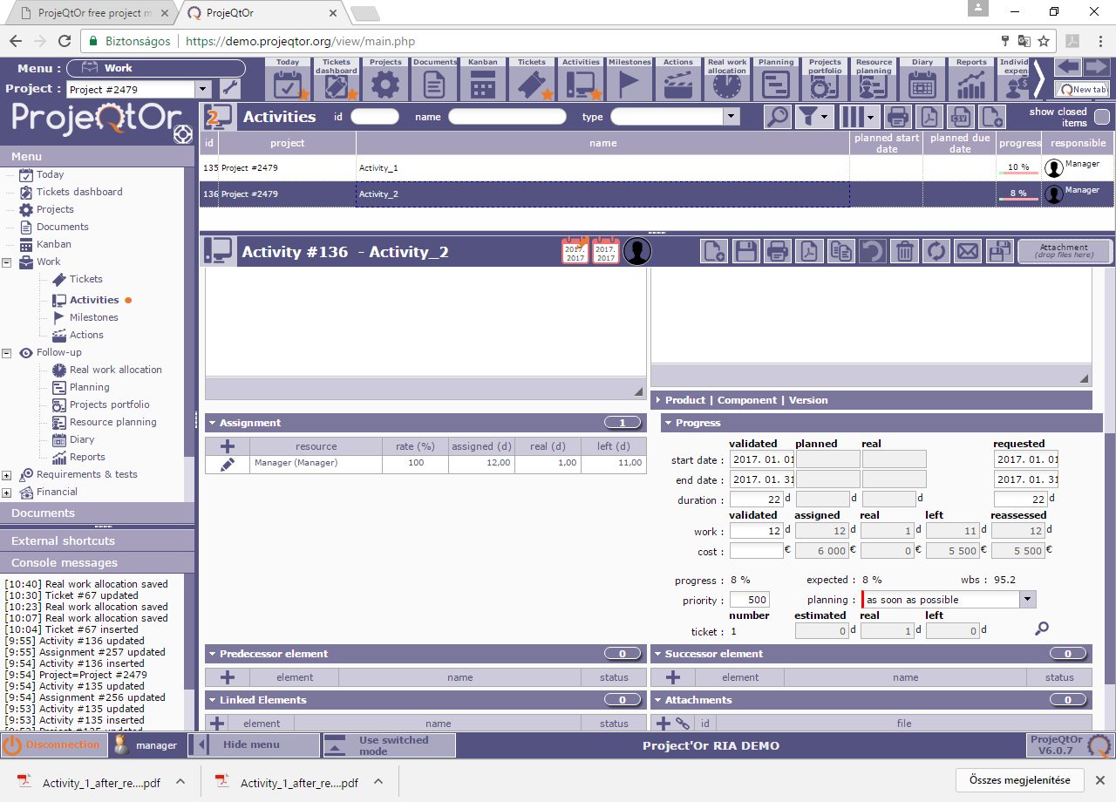
- On this list you can see 1-1 day real work on both Activity, which is not correct.
The correct datas should be:
Activity_1: 0 day real work
Activity_2: 1 day real work
